Kerry Coastal Clean-up Coordination Service
  - Harvey Smith / T00264389

Scenario Interpretation
Kerry Coastal Clean-up Coordination service is a service that wishes to provide an easy way for Coordinators, leaders and volunteers to share information regarding events, equipment or other arrangements. The system should allow volunteers to register themselves for events and have the organisation of said events handled by staff. These events need to be coordinated well regarding equipment, location, safety etc. This requires good communication between all staff and volunteers, making it the most important part of this system and should be prioritised. There are a number of current issues with the service, mainly regarding uncertainty or fragmentation which are further detailed in my problem statement. There are a few uncertainties regarding what checks are to actually be done prior to advertising or who has authority to enact certain decisions in the system, so assumptions will be made to rectify this. The desired outcome of this system is a strong coordinated service that tracks equipment, volunteers and their groups, events and notifies all relevant parties when changes are made to any of these parts.

Task 1: Classify Statements
Statement | Classification | Reason
Kerry Coastal Action Partnership coordinates volunteer clean-up events at beaches, harbours and coastal access points | Business rule | Domain rule stating the purpose of Kerry Coastal Action Partnership
Local groups propose events | Assumption | Believed to be true but will require verification or further definition if this is a rule
The partnership helps with permissions, volunteer registration, equipment, waste collection and reporting. | Business Rule | Domain rule stating how the partnership assists the local groups
Event details, volunteer lists, equipment requests and waste arrangements are managed through email, forms and shared calendars | Problem Evidence | Describes the current situation and shows possible data fragmentation among emails, forms and calendars
A proposal identifies the site, preferred date, organiser, expected volunteers and type of clean-up | Business rule | Domain rule stating the requirements for a proposal
Some sites need landowner, harbour or local-authority permission | Business rule | Domain rule detailing site permissions
A proposed event should not be advertised as confirmed until required checks are complete | Requirement | Domain rule stating correct procedure for advertising proposed events
Site conditions include access, parking, tide times, known hazards and suitability for different volunteer groups | Business Rule | Domain rule stating requirements for site conditions
A site may remain usable if the meeting point or clean-up area changes | Business Rule | Domain rule detailing site reuse
Several groups may propose nearby events | Business Rule | Domain rule detailing group proposals
The partnership may combine events, separate areas or discourage duplication, but the decision process is informal | Risk | Creates strong likely-hood of errors such as fragmentation in the system
Volunteers may register individually or through schools, clubs and community organisations. | Problem Evidence | Can cause fragmentation if not correctly managed. Will occur if an individual can register themselves and through a school
Group organisers sometimes provide only estimated numbers until shortly before the event | Problem Evidence | Describes the current situation and shows possible short-notice issues for a variety of factors if estimation is off
Registrations may include practical accessibility, communication and supervision requirements | Requirement | Describes factors on registration that should be included in the system
Event leaders need enough information to prepare safely without receiving unnecessary personal details | Requirement | Describes factors for safe preparation
A volunteer may transfer to another event, arrive without registration or withdraw | Business Rule | Domain rule for volunteers
Capacity depends partly on leaders, equipment and waste collection rather than only the physical site | Business Rule | Domain rule for capacity
Events require gloves, litter pickers, bags, high-visibility clothing, first-aid supplies and sometimes specialist containers | Requirement | Describes items required for events
Equipment may be reserved across several events and can return wet, incomplete or damaged | Problem Evidence | Issue that allows damaged property and assumes is acceptable
Event leaders have different experience and training | Risk | Risky as can result in very different levels of training
Larger or dispersed sites may require several leaders | Business Rule | Domain rule describing possibly more leader requirements
A leader assignment can remain provisional while availability or permission is confirmed | Problem Evidence | Can cause issues where no leader is available for a confirmed event
Waste collection may be arranged with a council, harbour or contractor | Business Rule | Domain rules describing waste collection arrangements
Different waste types may require separate handling | Business Rule | Domain rule describing possible separate handling of waste
A collection vehicle may have limited access or capacity | Problem Evidence | Issues can arise when a vehicle doesn’t have enough capacity
Weather, tides, access restrictions or insufficient leadership may cause relocation, postponement, shortening or cancellation | Problem Evidence | Describes the current situation and shows potential issues that can delay or cancel events
Messages to volunteers and partners are not always updated consistently | Problem Evidence | Inconsistent messages will cause problems for many events
After the event, leaders record attendance, areas covered, waste quantities, unusual items, equipment returned and incidents | Business Rule | Domain rule describing rules for attendance recording
Waste figures may be estimated using bags, weight or collection reports | Business Rule | Domain rule allowing estimation
The coordinator needs views of events awaiting approval, leader and equipment gaps, changed events, outstanding waste collection and incomplete reports | Requirement | Requirement stating the needs of a coordinator in relation to views of events
Emergency response and environmental enforcement are outside scope | Problem Evidence

Task 2: Business Problem Statement
There are a number of problems throughout this system. Event details, volunteer lists, equipment requests and waste arrangements are managed through email, forms and shared calendars which can cause fragmentation. Due to this, data will be spread among a number of different data collection methods and will cause confusion or missing data. Because volunteers may register individually or through schools, clubs and community organisations, duplication could occur here if someone is to register on their own, but then be registered by their school. Because Group organisers sometimes provide only estimated numbers until shortly before the event, issues could arise as if the estimated numbers differ greatly from the estimation (numbers being much higher or lower than predicted), leaders could come overprepared or worse, underprepared and not have enough equipment for the event. Equipment may be reserved across several events and can return wet, incomplete or damaged which can encourage people to not take proper care of equipment. If there is no penalty or issue with returning a broken piece of equipment, then why would anyone need to care too much about the condition of equipment, it promotes faulty equipment which can be a safety hazard. If a leader assignment can remain provisional while availability or permission is confirmed, it could end up having an event not have a leader available at the time of the event causing the event to be postponed, cancelled or urgently needing a new leader to take over the position. A collection vehicle may have limited access or capacity, this is a problem as if the collection vehicle does not have enough capacity required for the event, it could cause delays or if underprepared jeopardise the whole event. Weather, tides, access restrictions or insufficient leadership may cause relocation, postponement, shortening or cancellation. Anything that can risk cancelation of an event is a problem that needs to be planned around better. If messages to volunteers and partners are not always updated consistently, it can cause issues with volunteers maybe not showing on time, or at all if not correctly informed of a postponement or time change. It could also cause volunteers to show up early or on the wrong date prior to the event which will cause angry volunteers due to a lack of planning.

Task 3: Define purpose and scope

Purpose Statement
The proposed Kerry Coastal Clean-up Coordination Service will be used to manage and organise coastal cleaning events, propose new events, host events, volunteer registration, site quality, leader and equipment assignment, waste collection and reporting on completed events

Scope Definition
In Scope | Out Of Scope For Initial Release
Volunteer registration | Social Media Integration
Leader and equipment assignment + management | Emergency response and environmental enforcement
Messages sent out to Volunteers | Website design
Reporting post event | Advertising/Marketing campaign
Waste Collection | Volunteer Pay

Task 4: Stakeholder Analysis
Stakeholders | Goals | Concerns | Influence | Expected Interaction
Coordinator | Coordinate and manage events, notify relevant parties of events | Are relevant parties notified when I create or update an event? | High | Input and edit information regarding events
Volunteer | Register for events and receive information on times, dates and location | Is this information accurate? Will it change? Will I be notified? | Medium | Register and view event information
Event Leader | Access relevant information regarding volunteers and events to lead events effectively | Is my level of training good enough to lead a specific event? Do I need more leaders to help? | High | Get info on events and volunteers
Waste Partner | Receive information on waste types and estimated waste amounts | Are waste estimate figures accurate? | Low | Check waste types and waste amounts for events
Group Organiser | Organise groups of volunteers and assign them to specific events | Are volunteers notified or can I contact them when I decided to assign them to a specific group? | High | Add volunteers to groups and notify/contact them
Equipment Volunteer | View equipment inventory, and make relevant changes regarding inventory stats | Equipment may be returned still wet, incomplete or unsuitable for next event, what do I do with them? | Low | View inventory and update numbers, quality etc.

Task 5: Functional Requirements
ID | Functional Requirement | MoSCoW | Source/Rationale
FR01 | A proposed event should not be advertised as confirmed until required checks are complete | Must | Coordinator - Stake Holder Evidence
FR02 | Registrations may include practical accessibility, communication and supervision requirements | Should | Scenario – Volunteers and group arrangements
FR03 | Event leaders need enough information to prepare safely without receiving unnecessary personal details | Must | Scenario – Volunteers and group arrangements
FR04 | Events require gloves, litter pickers, bags, high-visibility clothing, first-aid supplies and sometimes specialist containers | Must | Scenario - Equipment, leaders and waste collection
FR05 | The coordinator needs views of events awaiting approval, leader and equipment gaps, changed events, outstanding waste collection and incomplete reports | Must | Scenario - Disruption, completion and reporting

Task 6: Non-Functional Requirements
ID | Quality Category | Measurable Requirement | Rationale
NFR01 | Availability | The system should always be available for all users so event information can be accessed | Supports daily operations
NFR02 | Protection | Private volunteer information can only be accessed by the appropriate people | Protects volunteer info
NFR03 | Availability | All necessary parties should be notified when changes are posted | Supports daily operations
NFR04 | Accessibility | System should be navigable on both desktop and mobile, and should support screen readers for the visually impaired | Supports accessibility for user
NFR05 | Accessibility | Help sections should be included on the system providing information on how to use the system for new users | Supports new users

Task 7: Rules, Assumptions, Constraints and Risks
Category | Statement
Risk | The partnership may combine events, separate areas or discourage duplication, but the decision process is informal
Risk | Event leaders have different experience and training
Rule | Kerry Coastal Action Partnership coordinates volunteer clean-up events at beaches, harbours and coastal access points
Rule | The partnership helps with permissions, volunteer registration, equipment, waste collection and reporting.
Rule | A proposal identifies the site, preferred date, organiser, expected volunteers and type of clean-up
Rule | Some sites need landowner, harbour or local-authority permission
Rule | Site conditions include access, parking, tide times, known hazards and suitability for different volunteer groups
Rule | A site may remain usable if the meeting point or clean-up area changes
Rule | Several groups may propose nearby events
Rule | A volunteer may transfer to another event, arrive without registration or withdraw
Rule | Capacity depends partly on leaders, equipment and waste collection rather than only the physical site
Rule | Larger or dispersed sites may require several leaders
Rule | Waste collection may be arranged with a council, harbour or contractor
Rule | Different waste types may require separate handling
Rule | After the event, leaders record attendance, areas covered, waste quantities, unusual items, equipment returned and incidents
Rule | Waste figures may be estimated using bags, weight or collection reports
Assumption | Local groups propose events

Task 8: Stakeholder Clarification Questions
- “What information is needed on each volunteer?”
- “What do we do with unsuitable equipment?”
- “Where can I get information about events?”
- “When will I be notified if an event is postponed or cancelled?”
- “How should we notify volunteers about a postponement or cancelation?”
- “How often should we aim to host events?”
- “What safety precautions should we take on site?”

Task 9: User Stories
Story ID | Requirement | Role–goal–benefit user story
US01 | FR01 | As a Coordinator I want to complete required checks so that I can advertise confirmed events
US02 | FR02 | As a volunteer I want to see relevant accessibility on registration forms so that I can complete registration unaffected by my disability
US03 | FR03 | As an event leader I want to have enough relevant information so that I can prepare safely for events
US04 | FR04 | As a waste partner I want to have the right equipment so that I can safely do my job
US05 | FR05 | As a Coordinator I want to have views of events so that I can safely and effectively coordinate events

Task 10: Acceptance Criteria

Selected Story 1: US01
  - Story
“As a Coordinator I want to complete required checks so that I can advertise confirmed events”
Criterion | Observable Acceptance Condition
1 | If the event is not marked as “Checked”, attempting to advertise on the system will fail
2 | Advertising an event on the system will notify all relevant parties
3 | Required checks can only be completed by users with “Coordinator” permissions
4 | Once required checks are complete, the event can be successfully advertised on the system

Given–When–Then example
Scenario: Attempt to advertise after checks as a coordinator
Given the event has been checked
And the user is a coordinator
When the user attempts to advertise
Then the event is successfully advertised

Questions revealed
- Can events be advertised elsewhere prior to checks?
- What are the required checks that must be done?
- Can anyone advertise the event once the coordinator completes the checks?
- Can checks be wrong/ false positives and still be advertised?

Selected Story 2: US02
  - Story
“As a volunteer I want to see relevant accessibility on registration forms so that I can complete registration unaffected by my disability”
Criterion | Observable Acceptance Condition
1 | High contrast modes should be available options for users
2 | Additional accessibility programs are supported on the system (screen reader apps)
3 | Documents should contain voice recorded alternatives
4 | Registration forms should be easily completed by someone with a disability

Given–When–Then example
Scenario: Registration does have relevant accessibility
Given registration does have relevant accessibility
When a user with a disability attempts registration
Then the user can complete registration

Questions revealed
- Are these options enough? Do we need more?
- Is the information the same through voice as it is text?
- Can images be described by built in accommodations?
- Will external and internal accessibility features overlap and cause issues?
- Can accessibility features be located prior to being turned on?

Selected Story 3: US03
  - Story
“As an event leader I want to have enough relevant information so that I can prepare safely for events”
Criterion | Observable Acceptance Condition
1 | Relevant parties feed accurate information to the event leader
2 | Information is checked prior to event leader receiving it
3 | Options to request more information are available if the current amount of information provided is deemed not enough/ missing
4 | Relevant information can be easily cross-examined to prepare safely
5 | Event leaders can inform relevant parties once safe preparation has been made for an event

Given–When–Then example
Scenario: Enough relevant information is provided
Given an event leader does have enough relevant information
When preparation for events begin
Then preparations will be completed
And the event will go forward

Questions revealed
- What constitutes as relevant information?
- How is information checked?
- Who checks the information prior to the event leader receiving it?
- What safety preparation is done?
- How are relevant parties informed after checks?

Task 11: Identify Actors and Use Cases

Actor and stakeholder catalogue
Actor or Stakeholder | Type | Goal or Interest | Direct Interaction?
Coordinator | Primary Actor | Coordinate and manage events, notify relevant parties of events | Yes
Volunteer | Primary Actor | Register for events and receive information on times, dates and location | Yes
Event Leader | Primary Actor | Access relevant information regarding volunteers and events to lead events effectively | Yes
Waste Partner | Offstage Stakeholder | Receive information on waste types and estimated waste amounts | Not necessarily
Group Organiser | Primary Actor | Organise groups of volunteers and assign them to specific events | Yes
Equipment Volunteer | Supporting Actor | View equipment inventory, and make relevant changes regarding inventory stats | Yes

Task 12: Use-case catalogue
Use Case | Primary Actor | Meaningful Outcome | Source Requirement
View Equipment Details | Equipment Volunteer | View equipment inventory and obtain information regarding all equipment | FR04
View Event Details | All Users | Obtain all information on a desired event | FR03
Create New Event | Coordinator | Create new event, assign volunteers to events etc. | Scenario Need
Edit Event Details | Coordinator | Change information regarding a pre-existing event | Scenario Need
Advertise Event | Coordinator | Allows advertisement of an event for registration after required checks are completed on the event | FR01
View Waste Details | Waste Partner | View estimated bag numbers required for events, waste types etc. | US04
View Volunteer Info | Coordinator | View specific information on volunteers or view your own information as a volunteer | NFR02
View Volunteer Groups | Group Organiser | View all created groups and information about them | Scenario Need
Perform Registration | Volunteer | Register yourself as a volunteer and have easy access to accessibility accommodations | FR02
Edit Volunteer Groups | Group Organiser | Change information regarding pre-existing event | Scenario Need
Create Volunteer Groups | Group Organiser | Create new groups, assign volunteers to groups etc. | Scenario Need
Manage Equipment Inventory | Equipment Volunteer | Submit information regarding inventory numbers | Scenario Need
Cancel Event | Coordinator | Cancel/postpone a pre-existing event | Scenario Need
Notify Parties | Coordinator | Notify all relevant parties of any relevant changes made regarding events, groups, volunteers etc. | NFR03
Record Attendance | Event Leader | Record volunteer attendance of events | Scenario Need
Generate Event Report | Event Leader | Create a report after completing an event | Scenario Need
End Volunteer Status | Coordinator | Remove a volunteer from the system, or remove yourself as a volunteer | Scenario Need
Edit Volunteers | Coordinator | Edit information regarding volunteers status

Task 13: Use-Case Diagram
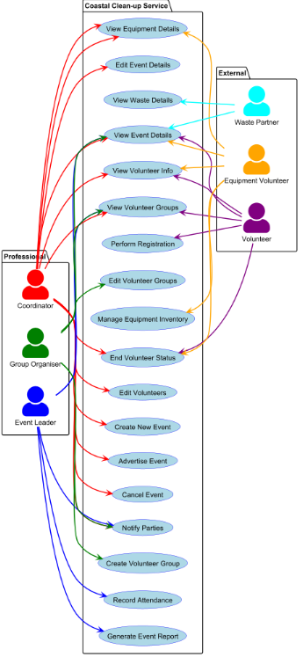

Task 14: Candidate-concept analysis
Candidate Term | Possible Interpretation
Registration | Physical/Digital item
Event | A scheduled activity
Equipment | A variety of items
Email | Method of information management
Forms | Method of information management
Shared Calendars | Method of information management
Site | Physical location of event
Volunteer | Role/member
Event Leader | Role/member
Group Organiser | Role/member
Coordinator | Role/member
Waste Partner | Role/member
Equipment Volunteer | Role/member
Collection Reports | Form created after event

Refined decisions
Candidate | Classification | Decision | Reason
Registration | Operation/event | Keep | Required by service for sign up
Event | Operation/event | Keep | Describes activities
Equipment | Conceptual class | Keep | Describes services apparatus
Email | Operation/event | Keep | Designated information method
Forms | Operation/event | Remove | Can cause fragmentation
Shared Calendars | Operation/event | Remove | Can cause fragmentation
Site | Conceptual class | Keep | Describes a location
Volunteer | Conceptual class | Keep | The service retains identity and status
Event Leader | Conceptual class | Keep | Differentiate between staff
Group Organiser | Conceptual class | Keep | Differentiate between staff
Coordinator | Conceptual class | Keep | Differentiate between staff
Waste Partner | Conceptual class | Keep | Differentiate between staff
Equipment Volunteer | Conceptual class | Keep | Differentiate between other volunteers
Collection Reports | Conceptual class | Keep | Required by service for post event reporting

Worked Glossary
Concept | Definition | Related Concepts
Registration | Used to register volunteers | Volunteer
Event | Activity hosted by service | Volunteer, Coordinator, Waste partner
Equipment | Apparatus owned by organisation | Equipment Volunteer
Email | Used to send information between relevant parties | Waste Partner, Coordinator
Site | Location used for events | Coordinator
Volunteer | A person registered to partake in events | Registration, Coordinator
Event Leader | A person who leads events safely | Volunteer, Group Organiser, Collection Reports
Group Organiser | A person who organises groups of volunteers for events | Volunteer, Coordinator
Coordinator | A person who coordinates events, edits information and registers volunteers for events | Event, Email, all members
Waste Partner | Partner organisations responsible for waste cleanup at or after events | Coordinator, Event
Equipment Volunteer | A volunteer who organises and manages equipment for an event | Equipment, Coordinator
Collection Reports | A form completed post event | Event Leader

Class Diagram
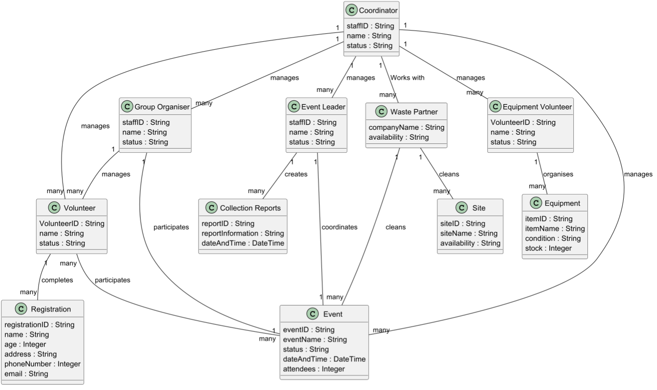

Task 15: Traceability
Business problem or stakeholder goal | FR | User story | Acceptance evidence | Use Case
A proposed event should not be advertised as confirmed until required checks are complete | FR01 | US01 | Only once required checks are complete can an event be advertised | Advertise Event
Registrations may include practical accessibility, communication and supervision requirements | FR02 | US02 | Registrations can be completed regardless of any physical or mental disability | Perform Registration
Event leaders need enough information to prepare safely without receiving unnecessary personal details | FR03 | US03 | Enough necessary information is provided in event details | View Event Details
Events require gloves, litter pickers, bags, high-visibility clothing, first-aid supplies and sometimes specialist containers | FR04 | US04 | Events cannot go forward unless the necessary checks are made on equipment and all relevant equipment is available | View Equipment Details
The coordinator needs views of events awaiting approval, leader and equipment gaps, changed events, outstanding waste collection and incomplete reports | FR05 | US05 | Coordinators can obtain all relevant views regarding events, equipment, leaders etc. | View Event Details, View Equipment Details

AI Declaration
The AI tool I used during the creation of this project was Google Gemini
Throughout my project I did not use Ai much, unless I was a little confused on how to complete a specific task. I did not use Ai to complete any tables, just to explain what information I need to find in my scenario to complete them. Other than this, once completed I used Gemini to determine if I was missing anything that the brief explicitly required, and then completed the work myself when what I missed/forgot was brought to my attention. All writing, diagrams, gherkin code were made completely by me alone.

Ai prompt examples
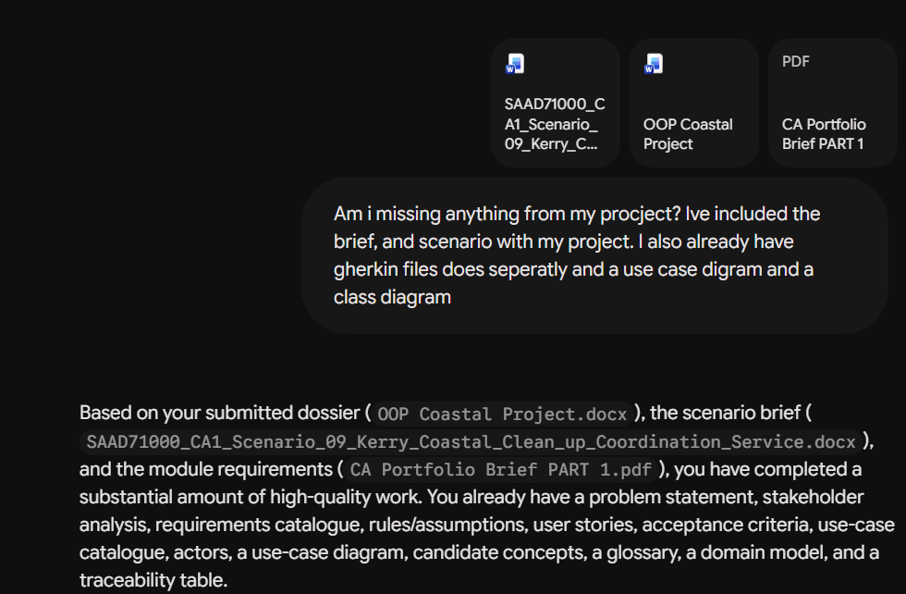
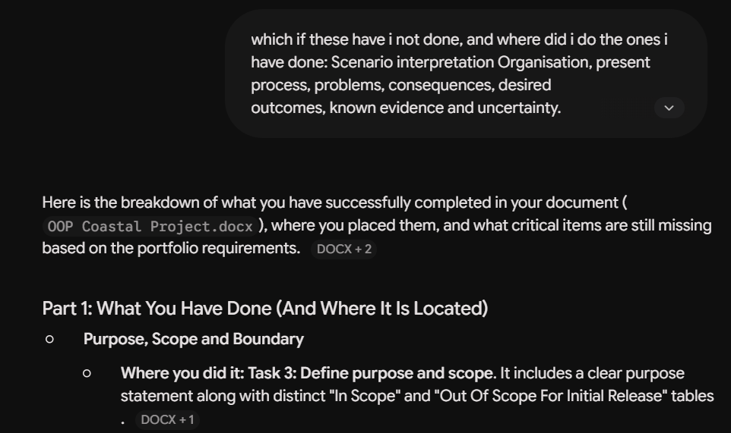
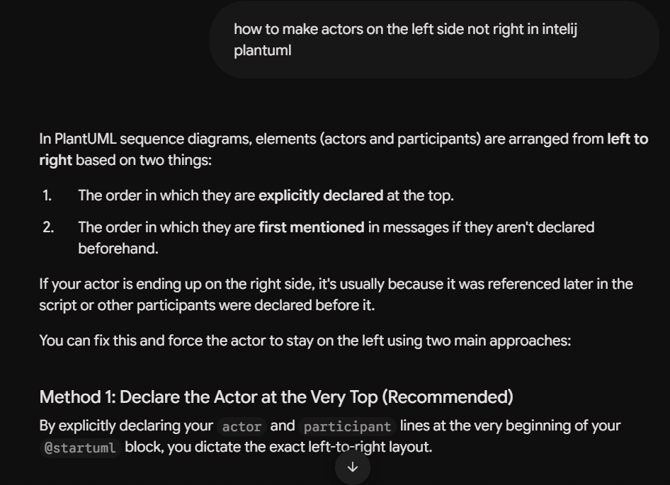
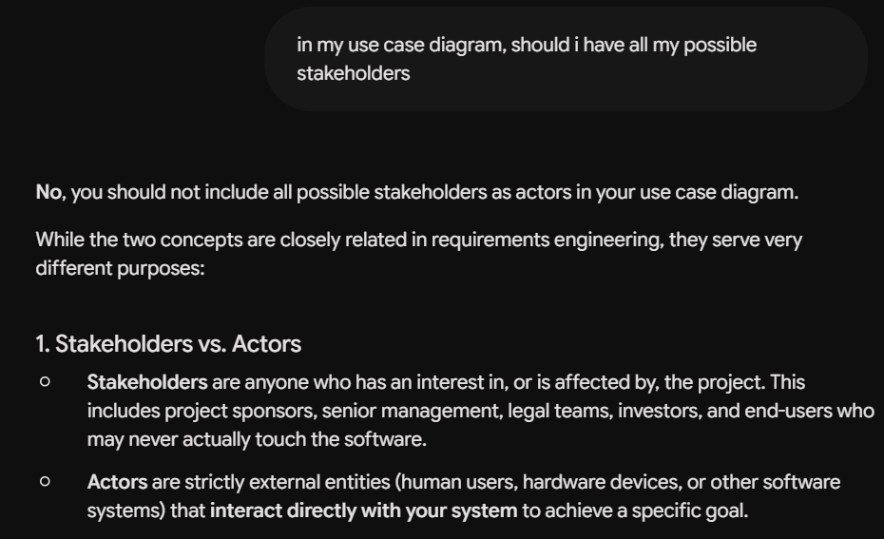

AI suggestion that was checked, modified or rejected
In one instance when I was learning how to use Gherkin, Gemini provided me an example for one of my user stories. Firstly, I did not want to use their example, just to have an idea of how to write them. However, gemini was not using the same sytax as Cucumber.io as there was no use of “Rule”. This through me off so I decided to just research elsewhere and do the Gherkin code completely myself rather than using Geminis input. Gemini would also tend to give Gherkin as very long detailed code which I saw on Cucmber.io this was bad, so avoiding Ai for this seemed best


